University of Cincinnati
Student Handbook

- Bachelor of Science in Nutrition & Dietetics
  - Community Nutrition
  - Sports Nutrition
- Didactic Program in Dietetics (DPD) Certificate
Department of Rehabilitation, Exercise, and Nutrition Sciences
COLLEGE OF ALLIED HEALTH SCIENCES
Table of Contents
Program Directors, Faculty, and Staff 3
Advising 5
Mission, Goals, and Student Outcome Measures 7
Undergraduate Degree and Certificate Options 8
Bachelor of Science in Nutrition & Dietetics 9
Didactic Program in Dietetics (DPD), Certificate 9
Curriculum Requirements 9
Admission Requirements 10
Program Requirements 11
Prior Learning and Course Credit toward Program Requirements 12
Program Costs 12
Registered Dietitian Nutritionist Requirements 13
Policies and Procedures 15
Non-discrimination and Equal Opportunity 15
Protecting the Rights of Students 16
Protection of Privacy of Information 16
Access to Personal Files 19
Access to Student Support Services 19
Scheduling and Program Calendar 19
Online Exam Proctoring 19
Inclement Weather 19
Withdrawal and Refund of Tuition Fees 20
Insurance Requirements 20
Grievance Procedures 20
Disciplinary and Termination Procedures 21
Formal Assessment of Learning 21
Performance Monitoring and Retention 21
Remediation/Grade Replacement for Undergraduate Coursework 21
Verification Statements 22
Appendix A: Curriculum Guides 22
Appendix B: Procedures for Complaints 27
Handbook Acknowledgement 30

Program Directors, Faculty, and Staff

Program Directors and Department Chair:
Lindsey Mills, PhD, RD, LD
Undergraduate & DPD Program Director
Associate Professor
lindsey.mills@uc.edu

Sarah Couch, PhD, RD
Graduate & CP Program Director
Professor
sarah.couch@uc.edu

Kari Dunning, PhD, PT
Department Chair
Professor
dunninkk@ucmail.uc.edu

Nutrition and Dietetics Program Faculty:
Seung-Yeon Lee, PhD
Associate Professor
Seung-yeon.lee@uc.edu

Abigail Peairs, PhD
Associate Professor
Abigail.peairs@uc.edu

John Pantel, MS, RDN, LDN
Director of Clinical Education for Dietetics
Assistant Professor
john.pantel@uc.edu

Emily Van Walleghen, PhD, RD
Assistant Professor
emily.vanwalleghen@uc.edu

Francoise Kazimierczuk, PhD, RDN, CSSD, LD, ATC, CSCS, NSCA-CPT
Assistant Professor
francoise.kazimierczuk@uc.edu

Nutrition and Dietetics Program Staff:

Jamie Neiheisel
Program Coordinator
neiheijl@ucmail.uc.edu

Advising

The college academic advisor assists the student in completing necessary paperwork for such things as declaring a major or transferring into the major, registering for the correct courses, accepting transfer credits from other institutions, registering for graduation, etc. Students should meet with a college academic advisor each semester, preferably before registering for the next semester’s classes. All freshmen must meet with a college academic advisor each semester during their freshmen year, prior to registering for classes for the next semester.
http://www.cahs.uc.edu/academicadvising
Academic Advisor ______________________________________________

Office ________________________________________________

Phone ________________________________________________

E-mail ________________________________________________

The faculty mentor is a faculty member in the Department of Rehabilitation, Exercise, and Nutrition Sciences assigned to the student to assist in course selection, career planning, and progress toward the professional portfolio capstone requirement for graduation. Students should touch base with their faculty mentor each semester to discuss career plans and professional volunteer opportunities.
Faculty Mentor ______________________________________________

Office ________________________________________________

Phone ________________________________________________

E-mail ________________________________________________

If it is believed that the student may benefit from changing educational programs and/or career paths, both the academic advisor and faculty mentor will work with the student to discuss additional career options that may be more appropriate given the student’s interests, goals, and abilities.

Mission, Goals, and Student Outcome Measures
  - Mission of the Department of Rehabilitation, Exercise, and Nutrition Sciences
The Department of Rehabilitation, Exercise, and Nutrition Sciences prepares students to provide high quality health care within their respective fields. In collaboration with community-based partners, students acquire professional skills together with proficiency in critical thinking, effective communication, teamwork, cultural sensitivity, and service learning. Through their focus on wellness, prevention, injury or illness recovery, functional adaptation, and community participation, our programs share a commitment to improving human performance and well-being across the lifespan. The Department faculty value and engage in innovative teaching, service, scholarly activity, interdisciplinary collaboration, and leadership.
  - Mission of the Didactic Program in Dietetics (DPD)
The mission of the DPD Program at the University of Cincinnati in the College of Allied Health Sciences is to educate competent, socially responsible professionals and prepare graduates to successfully enter into an accredited dietetic internship program, employment related to food and nutrition, or graduate school. Through innovative teaching, didactic and experiential education, and scholarly work, graduates are prepared to make successful contributions in education, research, their communities, and their chosen profession. The program encourages students to strive for excellence in practice through commitment to those they serve and to lifelong learning.
  - Program Goals and Student Outcome Measures
DPD Program Goal One
To provide quality didactic instruction and experiential education during the two-year DPD Program to prepare graduates for accredited dietetic internship programs, graduate school, or careers in food, nutrition, or related professions.
DPD Student Outcomes and Measures
- Eighty percent (80 %) of undergraduate students enrolled in the Bachelor of Science in Nutrition & Dietetics DPD program will earn a bachelor’s degree and verification statement within 3 years of entering junior status (taking Advanced Nutrition I) and 80% of post-graduate students enrolled in the Certificate in DPD will earn a verification statement within 3 years of starting junior level classes.
- The percent of program graduates who apply for admission to a supervised practice program within 12 months of graduation and are accepted to a supervised practice program will be higher than the national average placement rate. Over a five year period, average scores on the student exit survey for all DPD student learning outcomes will indicate adequate to excellent ratings.
- Over a five year period, average scores on the DPD Graduate Survey for Student Learning Outcomes will indicate adequate to excellent ratings.
- Over a five year period, average scores on the Dietetic Internship Director Survey will indicate average to excellent ratings of program graduates in dietetic competency areas.
- Fifty percent (50%) of program graduates will apply for admission to a supervised practice program within 12 months of graduation.
DPD Program Goal Two
To prepare graduates during the two-year DPD Program who are accepted into and who complete an accredited dietetic internship to become competent entry-level dietetic practitioners.
DPD Student Outcomes and Measures
- Over a five-year period, 80% or more of program graduates pass the CDR credentialing exam for dietitian nutritionists within one year following first attempt.
- Eighty percent (80%) of program graduates will have obtained employment in dietetics or another health-related field and/or be enrolled in a continuing education program within 2 years of graduation.
- Eighty percent (80%) of program graduates who complete the DPD Graduate Survey will indicate a good to excellent rating of their perceived quality of education.

Undergraduate Degree and Certificate Options
  - The department offers several undergraduate options to accommodate a variety of nutrition and dietetic career paths.

Bachelor of Science in Nutrition & Dietetics
Completion of the Bachelor of Science in Nutrition & Dietetics curriculum meets the academic requirements for the Didactic Program in Dietetics (DPD). The Nutrition & Dietetics major provides students with the coursework requirements necessary to apply for an accredited post-baccalaureate dietetic internship and ultimately become a Registered Dietitian Nutritionist (RDN). These coursework requirements are set forth by the Accreditation Council for Education in Nutrition and Dietetics (ACEND) of the Academy of Nutrition and Dietetics. Students can choose either community or sports nutrition as his or her concentration. This is the traditional route to become a registered dietitian nutritionist where upon graduation the student would apply for an accredited dietetic internship. https://cahs.uc.edu/academic-programs/undergraduate-programs/dietetics.html

Didactic Program in Dietetics (DPD), Certificate
The Didactic Program in Dietetics Certificate (DPD) is designed for students who are interested in becoming a registered dietitian nutritionist. Upon completion of the DPD Certificate, students earn a verification statement confirming their eligibility to enter a dietetic internship. After completing a dietetic internship, students are required to pass the Commission on Dietetic Registration credentialing exam to become a registered dietitian nutritionist.
https://cahs.uc.edu/academic-programs/certificates-and-minors/didactic-program-in-dietetics.html

Curriculum Requirements
Foundation Knowledge, Skills, and Competencies
In order to receive accreditation, the DPD must provide a curriculum that covers the Foundation Knowledge and Skills identified by the ACEND. Taking the required courses within each major ensures that students meet all the requirements. Graduates must have attained knowledge and skills in areas such as nutrition, physical and biological sciences, social sciences, foods and food science, management, research, and communications. A list of the Foundation Knowledge and Skills and Competencies for Dietitians can be found on the Academy of Nutrition and Dietetics website. http://www.eatrightacend.org/ACEND/
  - Undergraduate Sample Schedules
It is highly recommended that students in the undergraduate programs follow the suggested curriculum schedules provided by the program director and/or academic advisor to ensure completion of required course pre-requisites and completion of all program requirements. The curriculum guides can be found in Appendix A of the handbook.

Admission Requirements

  - Bachelor of Science in Nutrition & Dietetics
Initial admission to the BS in Nutrition & Dietetics is open to all students who meet the admission requirements for the College of Allied Health Sciences listed below.
The University of Cincinnati has established academic success criteria for first-year applicants to bachelor's degree programs. UC admits students based on academic and non-academic factors and all students are encouraged to apply. For more information about first-year student admission requirements visit UC Admission Requirements at http://admissions.uc.edu/information/high-school.html.
Students transferring from another college or university must meet the above requirements and must have a GPA of at least of 3.0 in all previous college work and have completed a one semester general chemistry course with lab. Students must have earned a C- or higher in all college level science courses.
A baccalaureate degree with a minimum GPA of 3.0 is needed for students to be eligible for admission into the DPD Certificate Program. Students in the MS in Nutrition must work with their graduate advisor to determine appropriate timing of entry into the DPD Certificate.
  - Didactic Program in Dietetics Certificate
Prospective students must have:
A baccalaureate with a minimum GPA of 3.0 to be eligible for admission into the DPD Certificate Program. Students who have a GPA lower than 3.0 cannot use additional courses taken after completion of a baccalaureate degree to increase their GPA to meet the admissions requirements, and
Prospective DPD Certificate students must submit the following materials to be considered for admission:
- Completed DPD Certificate Application,
- Official copies of transcripts from all undergraduate and graduate colleges/universities attended. Transcripts from foreign institutions must include a credential evaluation from an organization approved by the Academy of Nutrition and Dietetics. Information about approved credentialing organizations can be obtained by going to the Academy of Nutrition and Dietetics website, and
- Additional materials, including course catalogs, descriptions, or syllabi, may be requested during the application review process to assist in determining which courses can be transferred into the DPD Certificate Program from undergraduate and graduate degrees.

Program Requirements
  - Bachelor of Science in Nutrition & Dietetics and Didactic Program in Dietetics Certificate

To remain in the program, students must:
- Maintain a 2.5 GPA with no less than C- in any Nutrition course,
- Adhere to policies and procedures, and
- Conduct themselves in a professional manner, adhering to the Student Code of Conduct found at http://www.uc.edu/conduct/Code_of_Conduct.html.

To complete an undergraduate program, students must:
- Complete all didactic course requirements (as above),
- Complete all general education and elective requirements pertaining to the major or certificate program in which the student is enrolled,
- Maintain a 2.5 GPA in the Nutrition & Dietetics major (3.0 GPA in the DPD Certificate Program),
- Complete a capstone project, and
- No outstanding financial or other program obligations.
The criteria above hold true for graduate students completing DPD coursework. In addition, the Graduate student must maintain satisfactory progress in the Graduate Program in Nutrition.
Information related to program completion requirements for the Certificate programs can be found at https://cahs.uc.edu/academic-programs/certificates-and-minors/didactic-program-in-dietetics.html

Prior Learning and Course Credit toward Program Requirements
This includes transfer credits, assessment of life experience, and articulation agreements.
Information regarding the transfer of course credits that match to equivalent classes at UC may be found at (https://admissions.uc.edu/information/transfer.html ).
Occasionally, equivalency for course content can be granted for life experience (this does not necessarily replace credit hours needed toward a degree or certificate). This may be accomplished by visiting the University’s Testing Services website at https://www.uc.edu/campus-life/testing-services.html You will follow the links to find out your specific PLA procedure.
An Articulation Agreement for the transfer of courses is in place for students transferring from Cincinnati State Technical and Community College and Sinclair Community College. Course equivalency, which has previously been determined through articulation agreements with other programs, does not require additional verification assuming that the content for the course being substituted and the substituting course has not changed.

Program Costs
Estimated Program Costs
 | Tuition & Fees (yearly) |  | Estimated Program Length | Estimated program cost at current rates
 | In State | Out of State | Years | In State | Out of State
Bachelor of Science in Nutrition & Dietetics | $14,000.00 | $29,334.00 | 4 | $56,000.00 | $117,336.00
Bachelor of Science in Nutrition & Dietetics | $14,000.00 | $29,334.00 | 2 | $28,000.00 | $58,668.00
Didactic Program in Dietetics Certificate | $14,000.00 | $29,334.00 | 2 | $28,000.00 | $58,668.00

Total cost for tuition and fees will vary depending on the length of time required for you to complete the program.
Housing and meal plan (room and board) rates are not included in tuition and fees and vary depending on accommodations and level of meal plan. The maximum annual academic year costs for room and board is $1​7,232. The estimated cost for books and supplies required average $1,500 per year. Total cost for books and supplies in the program vary. A white coat is required for food lab courses which costs approximately $50.
Go to http://financialaid.uc.edu/ for additional information on tuition and fees.
Financial aid and grants are available for all programs. For more information about your specific financial aid needs, visit http://financialaid.uc.edu/aid/scholarships.html. Nutrition scholarship opportunities are also available for current undergraduate and graduate students on the department website. Scholarship Opportunities

Registered Dietitian Nutritionist Requirements
To become a Registered Dietitian Nutritionist (RDN), you must:
- Complete academic requirements through an educational program accredited by the Accreditation Council for Education in Nutrition and Dietetics (ACEND); this is accomplished by completing a Didactic Program in Dietetics (DPD)
- Have a minimum of a baccalaureate degree from an accredited college or university;
- Complete an ACEND-accredited supervised practice program (minimum of 1000 hours);
- Pass the Commission on Dietetic Registration credentialing exam for dietitians.
Traditionally, students complete their academic requirements while receiving their baccalaureate degree and then apply for a dietetic internship through a competitive national computer matching process. The internship provides the supervised practice experience. Some internship programs combine the supervised practice with a graduate degree. After completing the internship, students are eligible to take the national registration exam.
  - Areas of focus
Students should start early to position themselves for the application process.
Cumulative grade point average
Most programs require a minimum Grade Point Average (GPA) of 3.0 or higher for application. Because acceptance to Supervised Practice/Internship Programs is very competitive, it is recommended that students earn a GPA well above the minimum for application (generally above 3.4). While all university grades are reviewed, emphasis is placed on the DPD GPA, Science GPA, and GPA from Nutrition and Foods courses.

Relevant work experience
Evidence that you are a productive, reliable, and competent worker is critical. Accumulating volunteer and work experience in nutrition and/or food service is very helpful. Some internships look for health care work experience. Length of employment in one position or in one organization is valued.

Activities
Supervised Practice Programs/Dietetic Internships look for students who are committed to becoming registered dietitian nutritionists and contributing to the profession of dietetics. Involvement in student organizations, such as the Student Dietetic Association, is strongly suggested. Students are also encouraged to become members of professional organizations. Membership in the Academy of Nutrition and Dietetics (AND) includes membership in the Ohio Academy of Nutrition and Dietetics (OAND). Members of the AND are also eligible to join the Greater Cincinnati Dietetic Association (GCDA). Student membership in these and other nutrition and food service professional organizations provide benefits including networking opportunities, eligibility for scholarships, and additional educational experiences beyond the classroom. Information about these organizations can be obtained from www.eatright.org http://www.eatrightohio.org or department faculty mentors.

Leadership
Most supervised practice programs give preference during the application process to students with leadership experiences. Volunteer or paid positions that require leadership skills are beneficial. Opportunities to develop or enhance leadership skills are also available with the Student Dietetic Association.

References
References are part of the application process for jobs or supervised practice experiences. Usually, supervised practice programs require references from one or more employers and two or more professors (frequently it is specified that at least one professor be from a nutrition course). It is important to develop relationships over time with people who may serve as references.
National Registration Examination
After successful completion of an accredited supervised practice experience, students must pass the national registration examination in order to become a registered dietitian nutritionist. Most employment opportunities will require the RD credential prior to applying for positions. Therefore, studying adequately and passing the registration exam on the first attempt is crucial. Registration examination information is available from the Academy of Nutrition and Dietetics Commission on Dietetic Registration (CDR) and from individual directors of dietetic internships. The examination is computerized and is taken at an approved computer testing facility. Currently, the registration exam content comes from the following domains:
21% Principles of Dietetics
45% Nutrition Care for Individuals and Groups
21% Management of Food and Nutrition Programs and Services
13% Foodservice Systems
Most states require certification or licensure in order for a registered dietitian to practice dietetics. Access http://www.eatright.org/HealthProfessionals/content.aspx?id=7093 for the list of licensure or certification requirements for each state.

Policies and Procedures
Following are policies and general information for students in the undergraduate and Certificate programs.

Non-discrimination and Equal Opportunity
The University of Cincinnati does not discriminate on the basis of disability, race, color, religion, national origin, ancestry, medical condition, genetic information, marital status, sex, age, sexual orientation, veteran status or gender identity and expression in its programs and activities.
The university does not tolerate discrimination, harassment, or retaliation on these bases and takes steps to ensure that students, employees, and third parties are not subject to a hostile environment in University programs or activities.
The university responds promptly and effectively to allegations of discrimination, harassment, and retaliation. It promptly conducts investigations and takes appropriate action, including disciplinary action, against individuals found to have violated its policies, as well as provides appropriate remedies to complainants and the campus community. The university takes immediate action to end a hostile environment if one has been created, prevent its recurrence, and remedy the effects of any hostile environment on affected members of the campus community.
UC is committed to the ideal of universal Web accessibility and strives to provide an accessible Web presence that enables all university community members and visitors full access to information provided on its websites. Every effort has been made to make these pages as accessible as possible in accordance with the applicable guidelines.

The Nutrition & Dietetics programs protect student civil rights and comply with the University of Cincinnati equal opportunity policies that are administered through the University of Cincinnati Office Of Equal Opportunity. Policies are available at https://www.uc.edu/about/equity-inclusion/equal-opportunity.html

Protecting the Rights of Students
All nutrition programs in the College of Allied Health Sciences (CAHS) have written policies and procedures that protect the rights of enrolled students and are consistent with current institutional practice. Policies and procedures are provided to students.

Protection of Privacy of Information
The Family Educational Rights and Privacy Act of 1974 (34 C.F.R. Part 99 - commonly known as FERPA), is the federal law that governs the release of and access to student education records. FERPA affords students certain rights with respect to their education records. These rights include:
The right to inspect and review your education records within 45 days of the day the University receives a request for access. Students should submit to the registrar, dean, head of the academic department, or other appropriate official, a written request that identifies the record(s) they wish to inspect. The University official will make arrangements for access and will notify the student of the time and place where the records may be inspected. If the records are not maintained by the University official to whom the request was submitted, that official shall advise the student of the correct official to whom the request should be addressed.
Copies of any portion of the record will be provided at a cost currently established at ten cents ($0.10) per page, excluding the official transcript of the student's permanent academic record for which the University's transcript policy and fee will apply.
The right to request an amendment of the student’s education record if the student believes it is inaccurate or misleading, or otherwise in violation of the student’s privacy rights under FERPA. A student who wishes to ask the University to amend a record should submit a written request to the University office responsible for the record, clearly identifying the part of the record the student wants changed and specifying why it should be changed. That office will notify the student of its decision. Contact the Office of the Ombuds at 513-556-5956 should you encounter difficulty in obtaining the requested record review. If the University office decides not to amend the record as requested, the student may request a hearing before the University’s Family Educational Rights & Privacy Act Committee. To request this hearing, contact the Office of the Registrar at 513-556-9900.
The right to provide written consent before the University discloses personally identifiable information from the student’s education records, except to the extent that FERPA authorizes disclosure without consent.
One exception, which permits disclosure without consent, is disclosure to school officials with “legitimate educational interest.” A school official is an employee, agent or other person acting on behalf of the University, to include: a person employed by the University in an administrative, supervisory, academic or research, or support staff position (including law enforcement unit personnel and health staff); a person or company with whom the University has contracted as its agent to provide a service instead of using University employees or officials (such as an attorney, auditor, collection agent, or enrollment/degree certification service facilitator); a person serving on the Board of Trustees; or a student serving on an official committee, such as a disciplinary or grievance committee, or assisting another school official in performing his or her tasks. A school official has a legitimate educational interest if the official needs to review an education record in order to fulfill his or her professional responsibilities for the University.
Upon request, the University also may disclose education records without consent to officials of another school in which a student seeks or intends to enroll.
The right to file a complaint with the U.S. Department of Education concerning alleged failures by the University to comply with the requirements of FERPA. The name and address of the Office that administers FERPA is:
Family Policy Compliance Office
U.S. Department of Education
400 Maryland Avenue, SW
Washington, D.C. 20202-5920
At its discretion, University of Cincinnati may provide “directory information” in accordance with FERPA provisions. Directory information is defined as that information which would not generally be considered harmful or an invasion of privacy if disclosed. Designated directory information at University of Cincinnati includes the following:
Category I: student’s name, dates of attendance, enrollment status, degrees conferred and dates, honors and awards, college, class, and major field of study
Category II: student identifier (non-Social Security Number), address, e-mail address, and telephone number
Students may block the public disclosure of directory information (all or by category) by submitting a completed "Directory Information Hold-Release Authorization Form” to the One Stop Student Service Center (University Pavilion, 2nd floor) or the Office of the Registrar (University Pavilion, 5th floor). This can be found at https://www.uc.edu/about/registrar/personal-info-changes/ferpa/ferpa-right-to-review.html
Please consider carefully the consequences of a decision to withhold directory information. A non-disclosure block with call for University of Cincinnati not to release any or all of your “directory information”. Thus, University of Cincinnati will deny any future requests for such information submitted by non-institutional third persons or organizations. University of Cincinnati will honor your request to withhold directory information but cannot assume responsibility to contact you for subsequent permission to release this information. Regardless of the effect upon you, the University assumes no liability as a result of honoring your instructions that such information be withheld. University of Cincinnati will honor requests for the non-disclosure of directory information until the student rescinds the request in writing (or by the form) to the UC Registrar’s Office.

Access to Personal Files
The student may review any material within his or her file under the supervision of a college academic advisor. The student does not have access to review any material received by the program that has been labeled as confidential from the source received, such as references to which the student has waived his or her access. Student files are confidential and are available only to the student and the program faculty.

Access to Student Support Services
A list of student support services including, but not limited to, health services, counseling, tutoring, testing, and financial aid resources can be found at https://cahs.uc.edu/current-students/resources.html

Scheduling and Program Calendar
The Office of the Registrar website www.uc.edu/registrar includes a detailed University Calendar listing dates such as beginning and ending dates of each semester, key registration dates, deadline dates, payment dates, exam dates, holidays, etc.

Online Exam Proctoring
DPD courses offered via distance education will have proctored online exams. Honorlock is an online proctoring service used by the university. Honorlock blends AI proctoring software and human proctors who are trained to support students. Honorlock includes technology to verify a student’s identity using a student’s camera and university issued student identification card. Honorlock has a comprehensive privacy policy that protects each student’s privacy.

Inclement Weather
When inclement weather threatens the safety of the University of Cincinnati community, the Senior Vice President for Administration and Finance may invoke University Rule 3361: 10-55-01 and declare an emergency closing.
The College of Allied Health Sciences will observe emergency closing protocol for all on-campus classes. During a university emergency weather closing, all college offices will be closed. CAHS CETIS will be available online 8:30 am – 5:00 pm to monitor the CETIS Help Desk email account as well as the online ticketing system. If you need assistance from CETIS during the closure, please send an email to cetishelp@uc.edu.
Students should clarify with their course instructors how the closure will affect assignments and deadlines, and whether class information from the missed session(s) will be posted on Blackboard, and/or if the class will meet virtually during the closure. For Supervised Practice Preparation, please refer to Blackboard for additional information.
As weather patterns and road conditions vary, each intern must use his own discretion when determining his own safety driving to his site.

Withdrawal and Refund of Tuition Fees
The complete withdrawal process and information about refund of tuition fees is available from the Office of the Registrar website. https://www.uc.edu/about/bursar/refunds/tuition-refund-appeals-process.html

Insurance Requirements
All students who register for six (6) or more credit hours are automatically assessed health insurance coverage unless they previously have waived coverage during the then current academic year.
There is no geographical limitation and coverage would thus be available as long as the activity is within the scope of the curriculum at the University of Cincinnati. The Office of Risk Management and Insurance is responsible for maintaining this insurance program, as well as adjusting any claims that may arise.

Grievance Procedures
A grievance process exists for the objective review of students’ concerns. Students are encouraged to voice concerns about problems encountered with the program. The resolution of these concerns will be consistent with the University’s established policies and procedures as contained in the Student Grievances Procedures handbook, available from the office of the Ombudsman (http://www.uc.edu/ombuds/).
Students are encouraged to discuss complaints and questions with their course instructor first. If the issue is not resolved satisfactorily, they are advised to contact their departmental advisor/mentor. If the issue is still in need of resolution, students should contact the UG Director. The director will work with the student and other personnel to resolve the issue.

Disciplinary and Termination Procedures
Students who fail to meet expectations and standards, due to misconduct or deficiencies in fulfilling required learning or supervised practice experiences, are subject to termination from the program.
Students whose cumulative grade point average drops below the 2.5 minimum will be placed on academic warning or probation by the Office of Student Affairs and will be advised to meet with their college academic advisor prior to enrolling in courses for the next semester. These students are also expected to meet with their departmental faculty advisor. Recommendations for tutoring and other assistance can be made during meetings with either the college academic advisor or departmental faculty advisor. It is extremely important that students with cumulative grade point averages below 2.5 seek assistance immediately to ensure that they are eligible to graduate as planned.

Formal Assessment of Learning
Students are awarded grades at the end of didactic courses as an indication of their performance in the course, and they are generally the culmination of assessment done throughout the semester. Assessment is normally in the form of written exams and assignments but may take other forms as well. Syllabi indicate the basis by which grades are derived.

Performance Monitoring and Retention
Student progress is reviewed at the end of each term by the Office of Student Affairs. Students who are in academic difficulty will be notified via email by the Office of Student Affairs. Academic Alert is notification that a student’s academic performance, after the most recent semester or whose UC GPA is below 2.5 (2.25 for Distance Learning students) regardless of credit hours attempted. Students in this circumstance will receive an Academic Alert email. This email is intended to serve as a reminder that continued below-average academic performance may result in Academic Probation, and possible Academic Suspension. An Academic Alert is not the same as being placed on Academic Probation; it is simply a way to alert the student that academic improvement is necessary.
Please see the Academic Progression section of the College of Allied Health Sciences Undergraduate handbook on the CAHS Academic Advising webpage.
https://cahs.uc.edu/current-students/academic-advising/undergraduate-handbook.html

Remediation/Grade Replacement for Undergraduate Coursework
Students with minimal chances of success in the program must be counseled into career paths that are appropriate to their ability.
The College of Allied Health Sciences’ Satisfactory Academic Progress Policy in the CAHS undergraduate handbook is intended to simplify and explain the rules and guidelines of good academic standings, academic alert, academic probation, academic suspension, and program dismissal. Please review the CAHS student handbook for details on the CAHS remediation process.
https://cahs.uc.edu/current-students/academic-advising/undergraduate-handbook.html
The UC grade replacement policy allows a student to repeat University of Cincinnati coursework, with the final grade awarded for the most recent class enrollment calculated into the cumulative grade point average rather than the final grade awarded for the original class enrollment. The total number of replaced University of Cincinnati credit hours may not exceed twelve (12) undergraduate semester hours. Students may repeat up to a maximum of four (4) undergraduate semester courses. Please visit the Registrars’ grade replacement webpage for more detailed instructions on the grade replacement procedure.
http://www.uc.edu/registrar/policies_and_procedures/grade_replacement.html

Verification Statements
Once a student has completed the DPD Certificate Program or Nutrition & Dietetics Undergraduate Program according to the program completion requirements, the student will earn a verification statement, making them eligible to enter an accredited dietetic internship. The DPD Program Director will prepare the verification statement following the university’s commencement. The DPD Director emails a digitally signed copy of the verification statement to each graduate.

Appendix A: Curriculum Guides

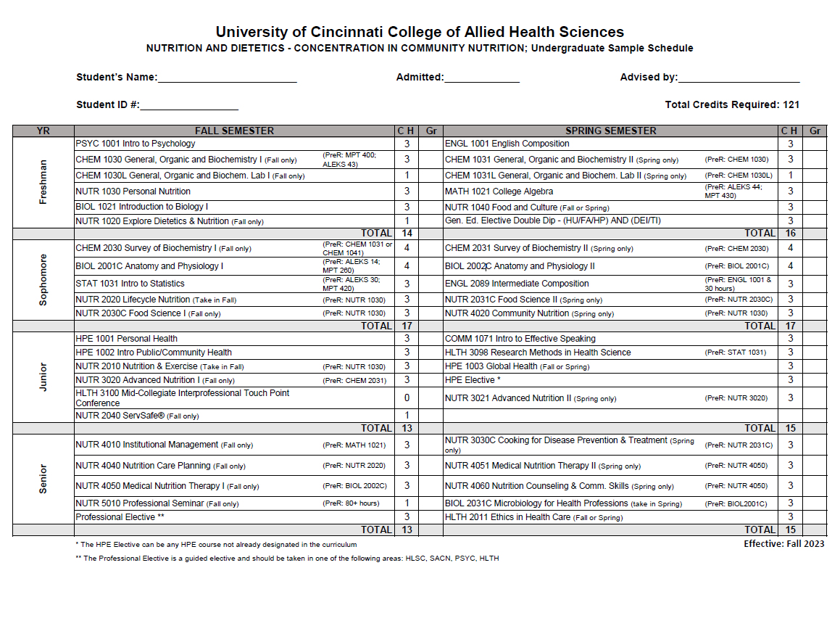
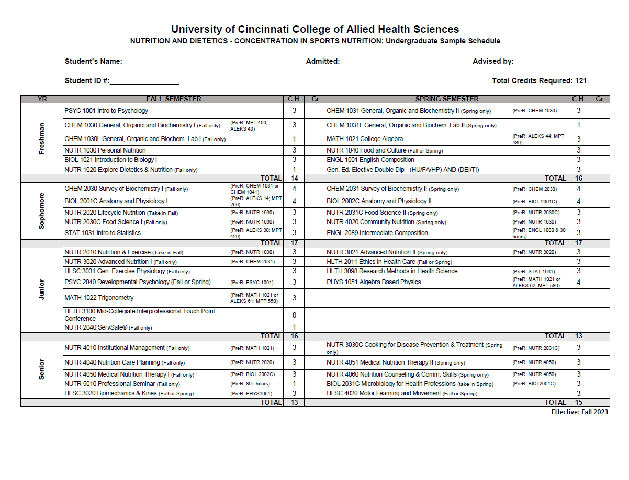
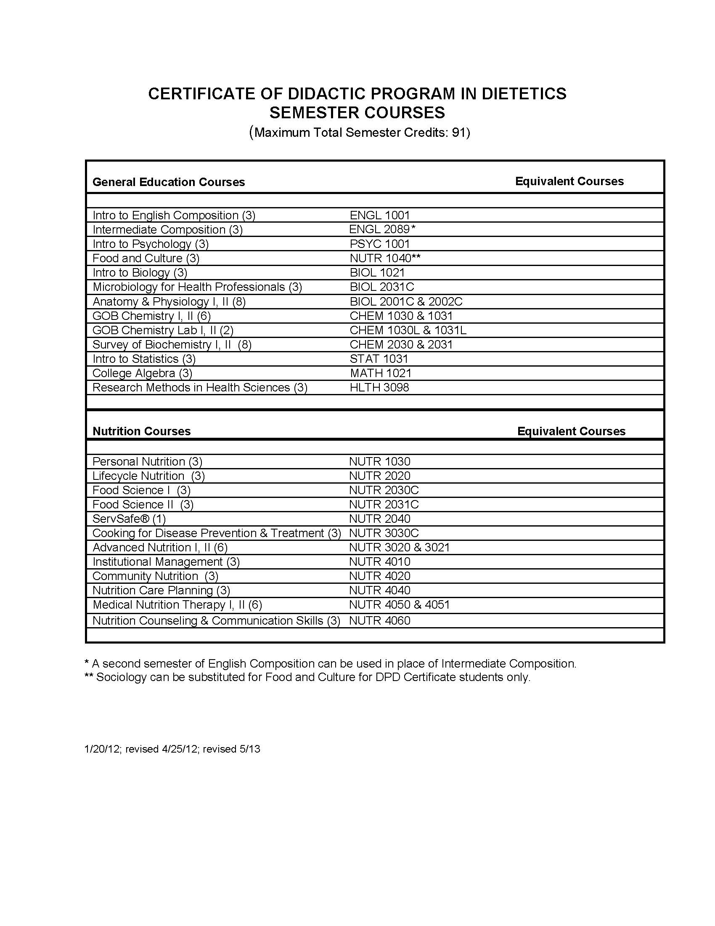

Appendix B: Procedures for Complaints
Procedure for Complaints about ACEND

Any individual, for example, student, faculty, dietetics practitioner, and/or member of the public, may submit a complaint about standards, policies, procedures, or conduct of ACEND. The complaint must be signed by the complainant. Anonymous complaints will not be considered. The following procedures will be used in the investigation of a complaint.

- AND Accreditation staff will forward all written complaints to the ACEND Chair and a public member within three weeks of receipt of the complaint.
- If the ACEND Chair and the public member determine that the complaint does not relate to the standards, policies, procedures, or conduct of ACEND, the complainant will be notified within two weeks of their review that no further action will be taken.
- If the ACEND Chair and the public member determine that the complaint does relate to the standards, policies, procedures, or conduct of ACEND, the complaint will be acknowledged in writing within two weeks of their review and the complainant will be provided a copy of the process for handling the complaint.
- The ACEND Chair will appoint a review committee that will consider the complaint, along with all relevant information, and recommend appropriate action to ACEND.
- ACEND or the ACEND chair may determine that legal counsel is needed to address the complaint. The AND staff will work with ACEND and legal counsel to identify a plan to address the complaint.
- ACEND will consider the review committee’s recommendation at its next scheduled meeting. If the complaint is determined to be unsubstantiated or not related to the standards, policies, procedures, or conduct of ACEND, no action will be taken. If the complaint is substantiated, appropriate action will be taken.
- The complainant will be notified of ACEND’s decision and action in writing within two weeks of the decision.
Procedure for Complaints to ACEND against Programs

ACEND has established a process for reviewing complaints against accredited programs in order to fulfill its public responsibility for assuring the quality and integrity of the educational programs that it accredits. Any individual, for example, student, faculty, dietetics practitioner or member of the public, may submit a complaint against any accredited or approved program to

ACEND. However, ACEND will not intervene on behalf of individuals or act as a court of appeal for individuals in matters of admissions, appointment, promotion or dismissal of faculty or students. It will act only upon a signed allegation that the program may not be in compliance with the accreditation standards or policies. The complaint must be signed by the complainant. Anonymous complaints will not be considered. The following procedures will be used in the investigation of a complaint against an accredited or approved program.

- AND Accreditation staff will forward all written complaints to the ACEND Chair within three weeks of receipt of the complaint.
- If the ACEND Chair determines that the complaint does not relate to the accreditation standards or policies, the complainant will be notified in writing within two weeks of the Chair's review that no further action will be taken.
- If the ACEND Chair determines that the complaint may relate to the accreditation standards or policies, the complaint will be acknowledged in writing within two weeks of the Chair's review and the complainant will be provided a copy of the process for handling the complaint.
- At the same time as the complainant is notified, the complaint will be forwarded to the program by certified mail. The administrative officers of the institution or organization sponsoring the program, currently on file with ACEND, will receive copies of the correspondence by first class mail. At the request of the complainant, the name of the complainant will be "blocked out" within the body of the written complaint that is sent to the program.
- The ACEND Chair will request the program to conduct a preliminary investigation and submit a report addressing the relevant accreditation standards or policies postmarked no more than 30 calendar days from receipt of the notification, as documented by return receipt of certified mail.
- The ACEND Chair may also request further information or materials relating to the complaint from the complainant, the institution, or other sources.
- The ACEND Chair will appoint a review committee to consider the complaint, along with all relevant information. The review committee will recommend appropriate action to ACEND at its next scheduled meeting.
- In determining the appropriate action, ACEND will consider the complaint, materials relating to the complaint, the review committee's recommendation, if any, and additional evidence provided by the program, if any.
- ACEND or the ACEND chair may determine that legal counsel is needed to address the complaint. The AND Accreditation staff will work with ACEND and legal counsel to identify a plan to address the complaint.
- If the complaint is determined to be unsubstantiated or not related to the accreditation standards or policies, no action will be taken.
- If the complaint is substantiated and indicates that the program may not be in compliance with the accreditation standards or policies, appropriate action will be taken, which may include, but is not limited to, scheduling an on-site visit of the program. If the complaint is substantiated and ACEND determines that the program is not in compliance with the accreditation standards or policies, ACEND may place the program on probation or withdraw accreditation or approval.
- The Program Director and administration of the sponsoring institution will be notified of ACEND’s decision and action in writing within two weeks of the decision. The complainant will be notified of the final decision and action when the reconsideration and appeals process expires.
- The program will have the right to request ACEND to reconsider a decision to place the program on probation or to withdraw accreditation or approval.
Accreditation Council for Education in Nutrition and Dietetics (ACEND) of the Academy of Nutrition and Dietetics (AND), 120 South Riverside Plaza, Suite 2190, Chicago, IL 60606-6995, 800/877/1600 ext. 5400. http://www.eatright.org/ACEND

Handbook Acknowledgement

Verification of University of Cincinnati Programs in Nutrition & Dietetics
Handbook, Policy, and Procedures Review

I, (printed name) ______________________________________, verify that I have reviewed the Undergraduate Student Handbook with regard to expectations of students participating in the University of Cincinnati Programs in Nutrition & Dietetics. This includes, but is not limited to, adherence to policies and procedures related to undergraduate educational programs and the Academy of Nutrition & Dietetics Code of Ethics for the Profession of Dietetics.

I have read and understand the policies and procedures with the program and agree to abide by them.

Signature:_____________________________________

Date: ________________________________________

