**Creating a Research Poster – Technical Specifications**

Technical Specifications provide a framework and set boundaries for the content presentation.

**Use a Template to:**

* Set the standard size, 36”x48”
* Create an organization, layout and spacing
  + **Logical Flow:** Arrange sections in a logical sequence that guides the viewer through the content; Reading a poster is typically left to right, then top to bottom
  + **Create a Visual Hierarchy:** Use headings, subheadings, font types and sizes to establish a clear hierarchy; easy to identify key sections and navigate through the poster
    - * Organize the sections by having most important sections (i.e., Results, Discussion, Methods) top left and center
      * Can use three columns to read top to bottom, then next column
  + **Alignment:** Align text and visual elements consistently to create a clean, organized appearance. This aids in readability and clarity.
* Set up Font Types and Sizes for various components

**Font Style and Sizes:**

There are two “styles of fonts”. They are called Serif and Sans Serif fonts.

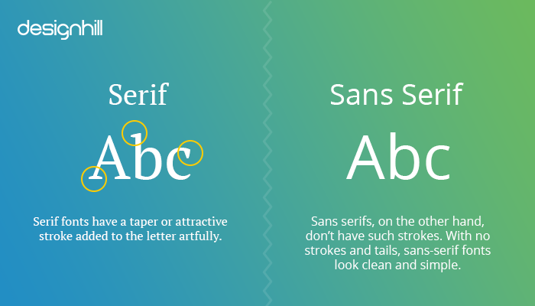

**Guiding Principles for fonts on a research poster:**

* Less is more, use only one to two different font styles to maintain a cohesive look
* Prioritize readability and professionalism, avoid decorative fonts
* Easy to read and visibly appealing
* Use one Sans Serif font if your poster does not contain multiple paragraphs of text in sections (body text)
* Use two fonts, Sans Serif for headings and Serif for body text, when your poster has a significant amount of body text in the sections

**Sans Serif Fonts:**

Sans Serif fonts show up clean and are easier to read at a distance. They are typically used for titles, headings, and small blocks of text. If you are going with only one font on the poster, choose a Sans Serif font. This is Calibri font and is a Sans Serif font.

**Common Sans Serif Fonts:**

* **Calibri**: modern font often used in academic and professional settings
* **Helvetica**: known for clarity and neutrality
* **Arial**: widely used, clean, and easy to read

**Serif Fonts:**

Serif fonts read better for body text, especially more than one paragraph. This is Georgia font and is a Serif font.

**Common Serif Fonts:**

* **Georgia**: Contemporary, maintains readability
* **Garamond**: Designed for clarity, contemporary look, maintains readability
* **Times New Roman**: A classic Serif font that is familiar and legible. Widely recognized and often used in academic and professional documents, providing a traditional and formal appearance.

**Font Sizes:**

Use the following guiding principles for font sizes:

* + **Title**: Use larger font size, 65-80 pt, bold to make it stand out
  + **Authors**: 54-60 pt, below
  + **Headings/Subheadings**: 36-60 pt to differentiate from body text.
  + **Body Text**: Should be around 32-50 pt for comfortable reading from a distance